D.Clock : Light And Shadow Interaction Using Spiral Shape

SeungHeon Doh

UNIST

Ulsan, 44919, South Korea

seung4298@unist.ac.kr

Young-Woo Park

UNIST

Ulsan, 44919, South Korea

ywpark@unist.ac.kr

# Abstract

D.Clock is using light and shadow interaction with spiral shape. Spiral shape makes continuous slope and aesthetic figure. This spiral shape help human recognition about vision. Using Temboo and Arduino, analog clock can contain IoT feature. D.Clcok contain scheduler with clock. Combine with clock and scheduler can make people more easily control their time and appointment.

# Author Keywords

Cognitive, Marr’s vision, Minimalism, Clock, Scheduling, Spiral, Temboo

# Introduction

Nowadays, smart phone’s penetration rate was keep increasing. According to eMarketer, in 2017, percentage of smartphone user was more than 48.8% in worldwide. In addition, smart watch market is more and more increased. Smart phone and smart watch was competitive goods. In result, Clock market was decline period in industrial cycle. Clock market need to new opportunity for overcome this threat.  
 For take a competitive advantage, clock need to additional feature. D.Clock focus on aesthetic and functional features. Using cognitive theory and combining IoT feature in clock.

# Related Work

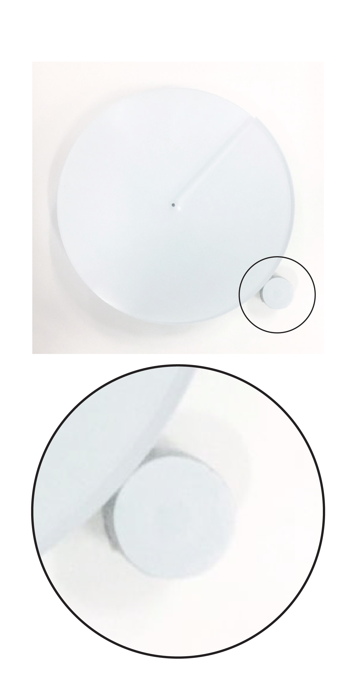

Marr [1] said about our cognitive level about vision. When human saw object, Human’s visual data is first perceived intensities and make a primal sketch. In primal sketch, People recognize light, virtual lines, curves. D.Clock’s spiral shape make a height difference and it makes shadow, virtual lines. D.Clock’s schedule interaction is using light.  
 Pierre and Stephane’s work [2] use spiral shape, for using visualized continuous and periodic data. Their main concern was potential about spiral shape’s data visualizing. D.Clock’s spiral shape is not related to data, but more concentrated in cognitive interaction.

# D.Clock Product Concept

D.Clock is combine clock and scheduler. Time is very important in current society. Why we see the clock is control our time. People have a plan for their time, feature, then People well control their daily life.

**Figure 2.** outer circle about D.clock

**Figure 2.** spiral shape about D.clock

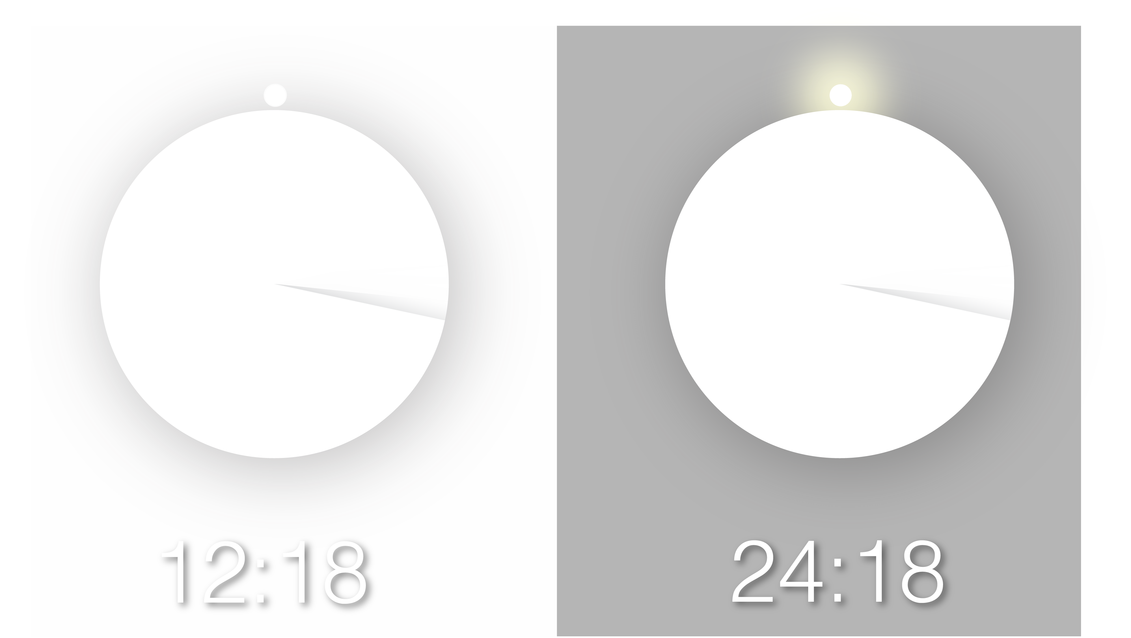

**Figure 1.** D.Clock in day context and Night context.

# Design Feature

D.Clock’s metaphor is moon and satellite. Moon have a reflect light and revolve earth. D.Clock focus on similarity about moon. Shadow line is express minute and outer circle express hour.  
 D.Clock’s material is acrylic. Acrylic express semi-transparent. When we show moon, we use telescope’s glass. Glass’s transparent interrupt our sight. So, D.Clock use acrylic.  
 D.Clock’s color is white. White’s characteristic is reflected light. White color help D.clock’s interaction, light.

# Interaction Techniques

D.clcok have a 3 interaction feature from physical shape and light.

## Spiral shape

First plane’s shape is spiral. According to figure 2, Spiral shape give continuous slope. Only starting point and ending point have a height difference. Physical shape makes a shadow line. This shadow line’s moving with stepper motor. 360 angle can be a minute hand.

Outer circle  
Outer circle show like a satellite. It revolves with center of main circle. In the circle. Circle contains led strip for light. Before 30 minute of schedule, led strips light has on. In result, user notify their appointment. (figure 2)

## Indirect illumination

When night, user hard to recognize the clock. Because of white color. So, the last plane takes a led strip and when light sensor’s light data less than 100, indirect illumination is on.

# Technical Implementation

D.Clock’s main function is clock, scheduler and indirect illumination. For realize function, D.Clock contain stepper motor, easy driver, light sensor, and LED strip.

## Structure

D.clock has a 4 plane. First is spiral shape. Second plane is for holding motor and sensors. Third plane contain outer circle and led.

**Figure 3.** Hardware structure about D.Clock.

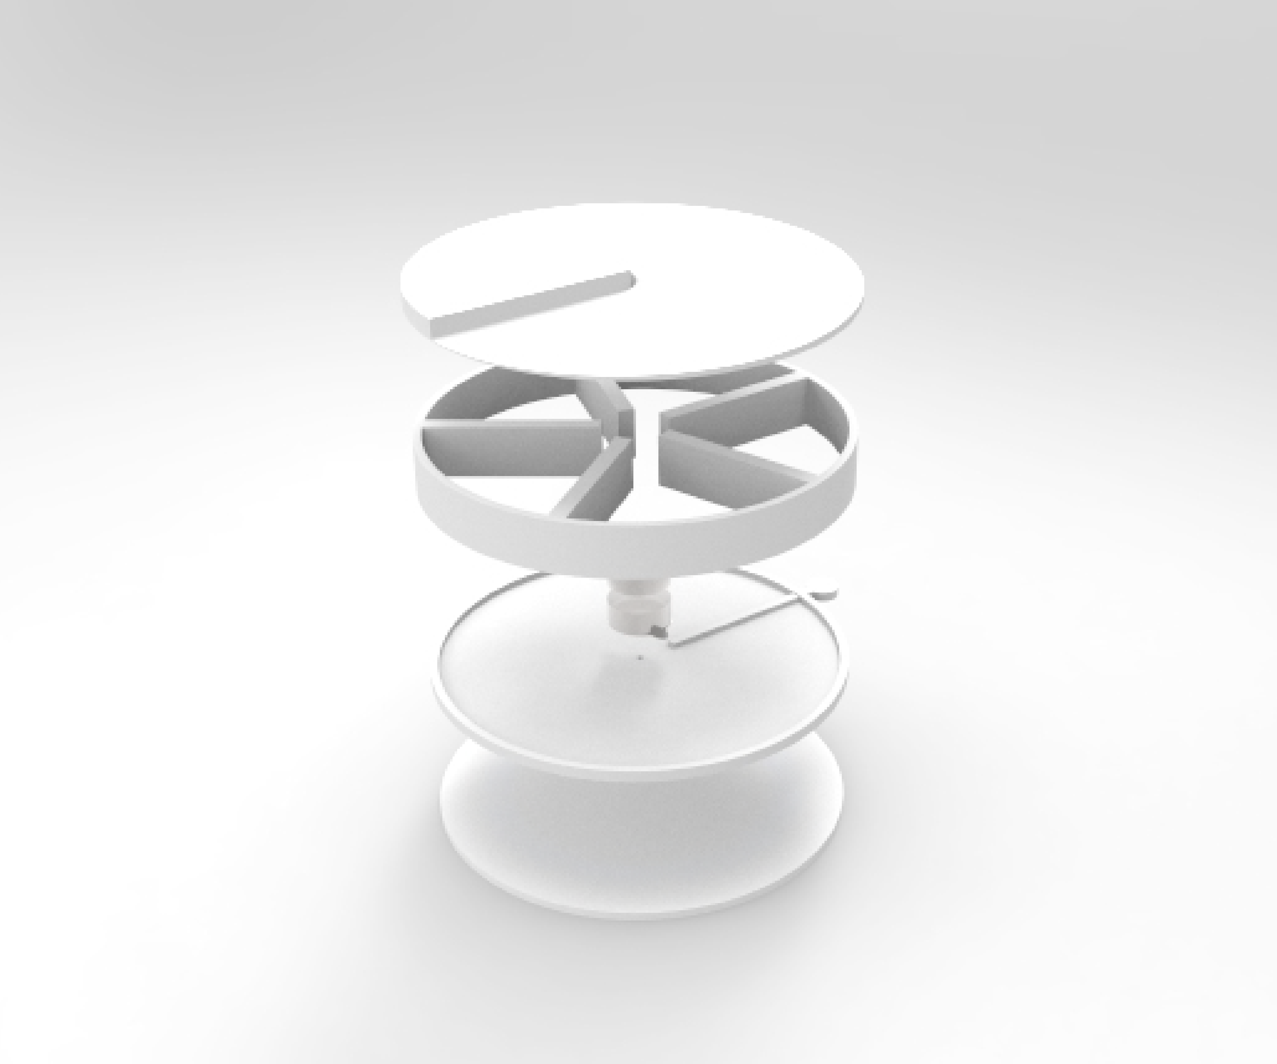

## Hardware

Using CNC cutting, spiral shape contains semi-transparent acrylic. CNC cutting’s problem is cutting surface. It is not continuous like stairs. In this stage, if using send paper, then clock cannot have semi-transparent hardware. Applying polish, thawing out external surface of acrylic.

## Software

Using Arduino Uno and temboo. Temboo take a google calendar data. When we know google account’s personal authority and calendar name, Arduino Uno take a data. Data’s format is software Processing. Using serial communication, processing sends char data to Arduino. Using char data, Arduino make a conditional sentence. So, Arduino and Processing make a scheduler function.

**Figure 4.** Software structure about D.Clock.

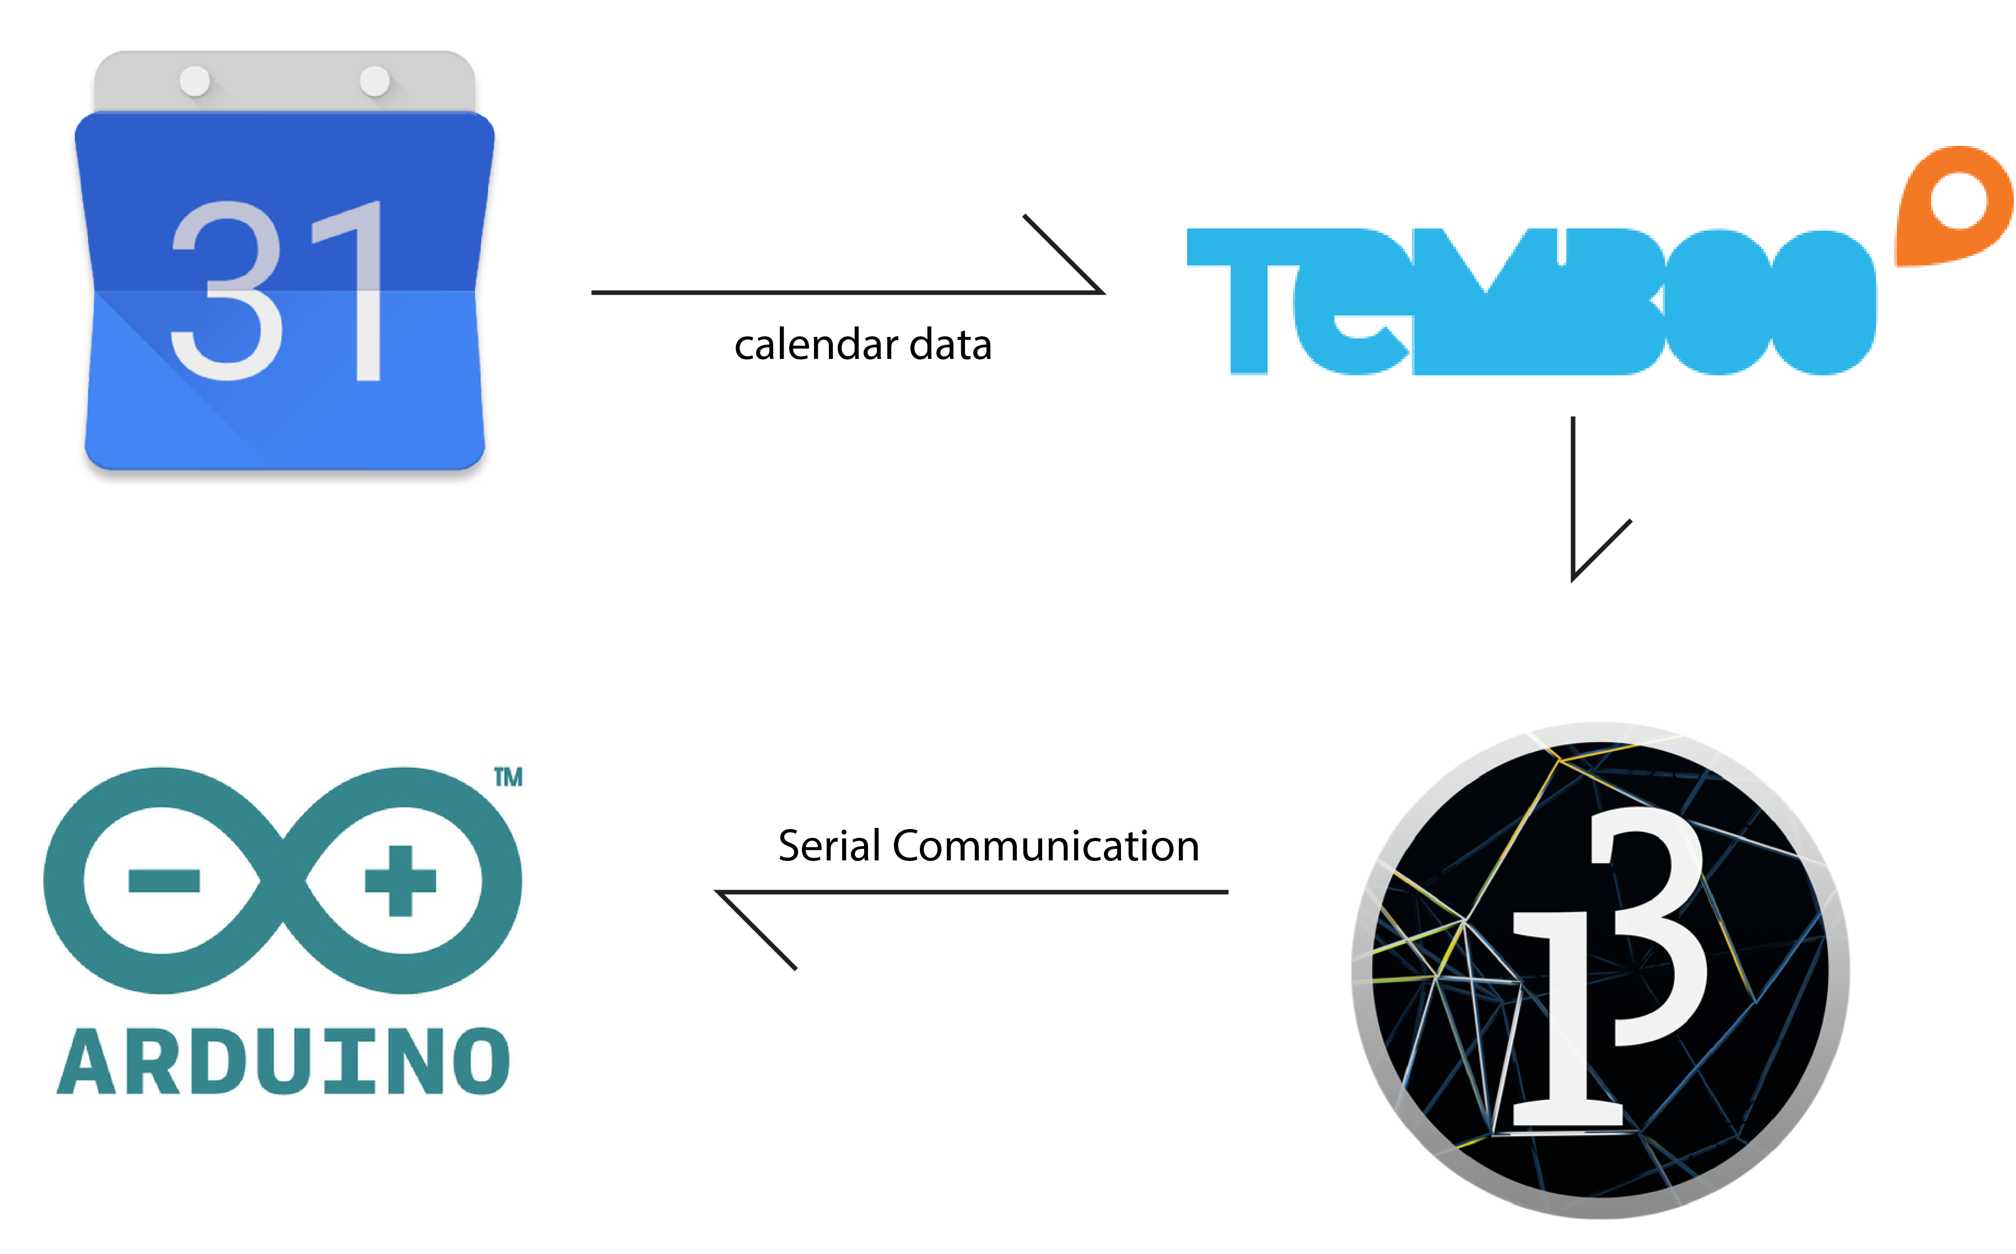

For indirect illumination, D.Clock use light sensor and led strip. When light sensor’s index change to less than 50, led strip turn on RGB 255,255,255.

# Design Implication

Spiral plane have a continuous height difference. Using difference, clock can show another level of data in spiral shape. Clock’s holding structure is not enough to holding motor. Considering motor’ vibration, D.Clock need to motor holder. And two plane have lots of height, using clock gear, change to only one motor clock.

# Summary and Conclusion

Spiral shape’s continuous feature makes an aesthetic interaction. People only concentrate on height difference’s shadow. In result, D.Clock can give to comfortable recognition to people.  
 Clock with scheduling function makes people more easily checking their appointment. When people focus on their work, people easily neglect phone’s alarming. Clock’s twinkle interaction can be steal the people’s vision.  
 indirect illumination is not only for light function. But also have an emotional light. Indirect light has less eye fatigue and abstract recognition. It can give more comfortable light interaction to people

# References

1. Pierre Dragicevic, Stephane Huot. 2002. CHI EA. Extended Abstracts on Human Factors in Computing Systems. 20 April, 2002 : 604 – 605  
   from http://dl.acm.org/citation.cfm?id=506505.
2. David Marr. Vision understanding complex information – processing system. 1982. MIT press : 23-30
3. Abigail Sellen. 2006. CHI EA. Extended Abstracts on Human Factors in Computing Systems. 22 April, 2006 : 1307-1312  
   from http://dl.acm.org/citation.cfm?id=1125694.